Table of Contents

1 PROJECT TITLE 4

2 PROBLEM STATEMENT 4

3 PROJECT DESCRIPTION 4

3.1 SCOPE OF THE WORK 4

3.2 PROJECT MODULES 4

3.3 CONTEXT DIAGRAM (HIGH LEVEL) 4

4 IMPLEMENTATION METHODOLOGY 4

5 TECHNOLOGIES TO BE USED 4

5.1 SOFTWARE PLATFORM 4

5.2 HARDWARE PLATFORM 5

5.3 TOOLS, IF ANY 5

6 ADVANTAGES OF THIS PROJECT 5

7 ASSUMPTIONS, IF ANY 5

8 FUTURE SCOPE AND FURTHER ENHANCEMENT OF THE PROJECT 5

9 PROJECT REPOSITORY LOCATION 5

10 DEFINITIONS, ACRONYMS, AND ABBREVIATIONS 6

11 CONCLUSION 6

12 REFERENCES 7

**Appendix**

**A: Data Flow Diagram (DFD)**

**B: Entity Relationship Diagram (ERD)**

**C: Use Case Diagram (UCD)**

**D: Data Dictionary (DD)**

**E: Screen Shots**

# Project Title

STATELY SOJOURN

# Problem Statement

The objective of the project is to develop a system that automates the processes and activities of a travel and. The purpose is to design a system using which one can perform all operations related to traveling.

# Project Description

## Scope of the Work

**EXISTING SYSTEM:**

In the present system a customer has to approach various agencies to find details of places and to book tickets. This often requires a lot of time and effort. A customer may not get the desired information from these offices and often the customer may be misguided. It is tedious for a customer to plan a particular journey and have it executed properly.

**PROPOSED SYSTEM:**

The proposed system is a web-based application and maintains a centralized repository of all related information. The system allows one to easily access the relevant information and make necessary travel arrangements. Users can decide about places they want to visit and make bookings online for travel and accommodation.

## Project Modules

**MODULES:**

The system is proposed to have the following modules:

Administrator module, travels module, routes module, reservations module and

Testimonials module.

**ADMINISTRATOR MODULE:**

This module provides administrator related functionality. Administrator manages all information and has access rights to add, delete, edit and view the data related to places, travels, routes, bookings, etc.

**TRAVELS MODULE:**

This module provides the details of various travel agencies. A user can select the appropriate agency depending on convenience and accessibility.

**ROUTES MODULE:**

This module provides information related to various routes connecting sources and destinations. For each route, information such as source, destination, fare, reservation details, pick up points etc are provides. Only administrator can add, delete, edit and manage the data. Users can only view the information.

**RESERVATIONS MODULE:**

This module provides functionalities that allow a user to book tickets or cancel previously booked tickets. The module maintains the details of all reservations made so far and allows administrator to either confirm or reject the bookings.

**TESTIMONIALS MODULE:**

Users of this application can post their opinions, complaints and suggestions regarding this portal and services to the administrator. Accordingly, the administrator can take various steps to act on the complaints and suggestions.

## Context Diagram (High Level)

**SDLC Methodology:**

This document plays a vital role in the development of life cycle (SDLC) as it describes the complete requirement of the system.

SPIRAL MODEL was defined by Barry Boehm in his 1988 article, “A spiral Model of Software Development and Enhancement. This model was not the first model to discuss iterative development, but it was the first model to explain why **the iteration models**.

As originally envisioned, the iterations were typically 6 months to 2 years long. Each phase starts with a design goal and ends with a client reviewing the progress thus far. Analysis and engineering efforts are applied at each phase of the project, with an eye toward the end goal of the project.

The steps for Spiral Model can be generalized as follows:

* The new system requirements are defined in as much details as possible. This usually involves interviewing a number of users representing all the aspects of the existing system.
* A preliminary design is created for the new system.
* A first prototype of the new system is constructed from the preliminary design. This represents an approximation of the characteristics of the final product.
* A second prototype is evolved by a fourfold procedure:

1. Evaluating the first prototype in terms of its strengths, weakness, and risks.
2. Defining the requirements of the second prototype.
3. Planning and designing the second prototype.
4. Constructing and testing the second prototype.

* The entire project can be aborted if the risk is deemed too great. Risk factors might involve development cost overruns, operating-cost miscalculation, or any other factor that could, in the customer’s judgment, result in a less-than-satisfactory final product.
* The existing prototype is evaluated in the same manner as was the previous prototype, and if necessary, another prototype is developed from it according to the fourfold procedure outlined above.
* The preceding steps are iterated until the customer is satisfied that the refined prototype represents the final product desired.
* The final system is constructed, based on the refined prototype.
* The final system is thoroughly evaluated and tested. Routine maintenance is carried on a continuing basis to prevent large scale failures and to minimize down time.

**The following diagram shows how a spiral model act like:**

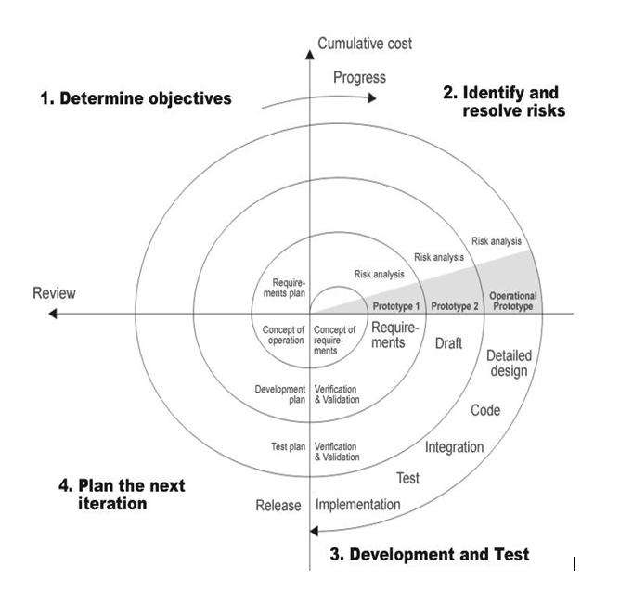

**Advantages:**

* Estimates(i.e. budget, schedule etc .) become more relistic as work progresses, because important issues discoved earlier.
* It is more able to cope with the changes that are software development generally entails.
* Software engineers can get their hands in and start woring on the core of a project earlier.

**Performance Requirements:**

Performance is measured in terms of the output provided by the application. Only when the requirement specifications are properly given, it is possible to design a system, which will fit into required environment. It rests largely with the users of the existing system to give the requirement specifications because they are the people who finally use the system. This is because the requirements have to be known during the initial stages so that the system can be designed according to those requirements. It is very difficult to change the system once it has been designed and on the other hand designing a system, which does not cater to the requirements of the user, is of no use.

The requirement specification for any system can be broadly stated as given below:

* The system should be able to interface with the existing system.
* The system should be accurate.
* The system should be better than the existing system.

The existing system is completely dependent on the user to perform all the duties.

**DFD (Context level Diagram):**

**Architecture flow :(N-Tier)**

N-Tier Applications can easily implement the concepts of Distributed Application Design and Architecture. The N-Tier Applications provide strategic benefits to Enterprise Solutions. While 2-tier, client-server can help us create quick and easy solutions and may be used for Rapid Prototyping, they can easily become maintenance and security nightmare The N-tier Applications provide specific advantages that are vital to the business continuity of the enterprise. Typical features of a real-life n-tier may include the following:

* Security
* Availability and Scalability
* Manageability
* Easy Maintenance
* Data Abstraction

The above-mentioned points are some of the key design goals of a successful n-tier application that intends to provide a good Business Solution.

# Implementation Methodology

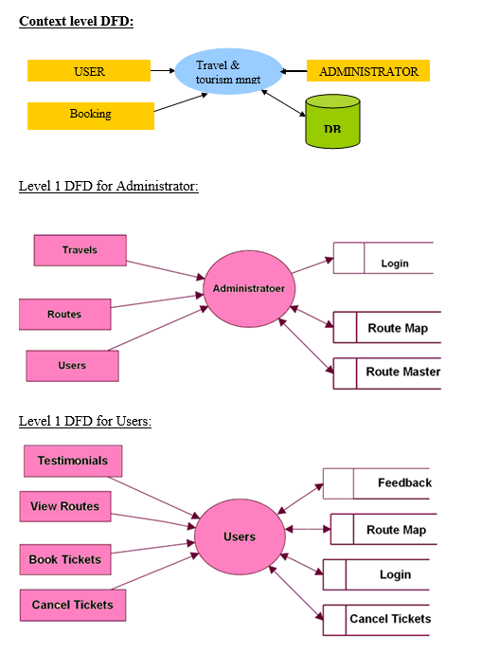

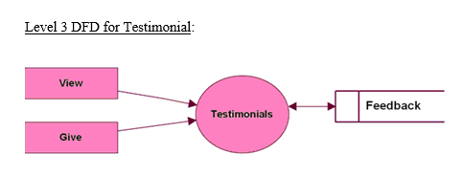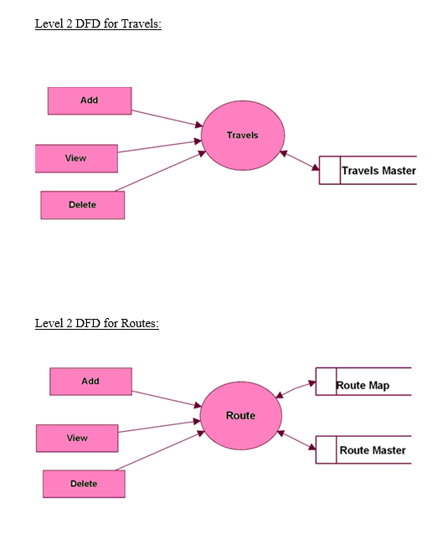

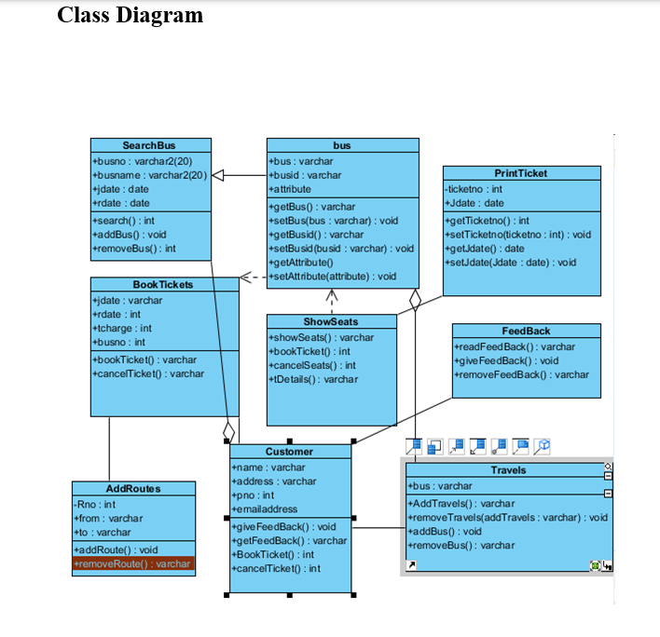

# Technologies to be used

## Software Platform

Technology : Java and J2ee

Web Technologies : Html, JavaScript, CSS

Web Server : Tomcat5.5

Database : MySql5.0

JDK Version : JDK1.5

## Hardware Platform

Hardware : Pentium

RAM : 1GB

# Advantages of this Project

* Saves time of users.
* Fast and accurate.
* Provides better service to the users.

# Assumptions, if any

NONE

# Future scope and further enhancement of the Project

* The tourism sector has undergone significant transformations in recent years, with a growing emphasis on domestic travel. A Domestic Tour Guide Portal Application serves as a digital platform connecting tourists with local guides, offering personalized experiences, and facilitating seamless travel.
* Domestic Tour Guide Portal Application in caters to the evolving needs and preferences of modern travelers.

# Project Repository Location

|  |  |  |  |  |
| --- | --- | --- | --- | --- |
| **S#** | **Project Artifacts (softcopy)** | **Location** | **Verified by Project Guide** | **Verified by Lab In-Charge** |
| 1. | Project Synopsis Report  (Final Version) | NONE |  |  |
| 2. | Project Progress updates | NONE |  |  |
| 3. | Project Requirement specifications | NONE |  |  |
| 4. | Project Report (Final  Version) | NONE |  |  |
| **S#** | **Project Artifacts (softcopy)** | **Location** | **Verified by Project Guide** | **Verified by Lab In-Charge** |
| 5. | Test Repository | NONE |  |  |
| 6. | Project Source Code (final version) with executable | NONEl |  |  |
| 7. | Any other document | C:\Program Files\Apache Software Foundation\Tomcat 10.1\webapps\statelysojourn\Login.html |  |  |

# 

# Definitions, Acronyms, and Abbreviations

|  |  |
| --- | --- |
| **Abbreviation** | **Description** |
| VS code | Visual Studio Code |
| OS | Operating System |
| HD | Hard Disk |
| RAM | Random Access Memory |

# Conclusion

The Stately Sojourn, providing the facility to plan any trip at fingertips.

The proposed system is a web-based application and maintains a centralized repository of all related information. The system allows one to easily access the relevant information and make necessary travel arrangements. Users can decide about places they want to visit and make bookings online for travel and accommodation.

# References

# <https://www.javatpoint.com/>

# <https://www.tcsion.com/LX/login#lx>

# 

**Annexure A**

**Data Flow Diagram (DFD)**

**(Mandatory)**



**Annexure B**

**Entity-Relationship Diagram (ERD)**

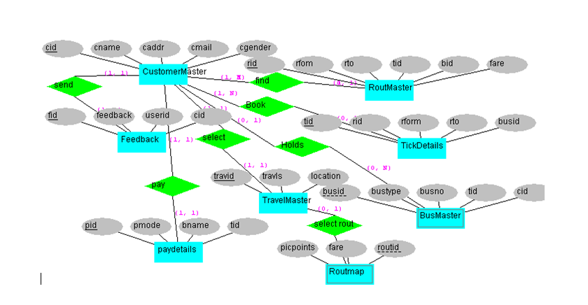

**Annexure C Use-Case Diagram (UCD)**

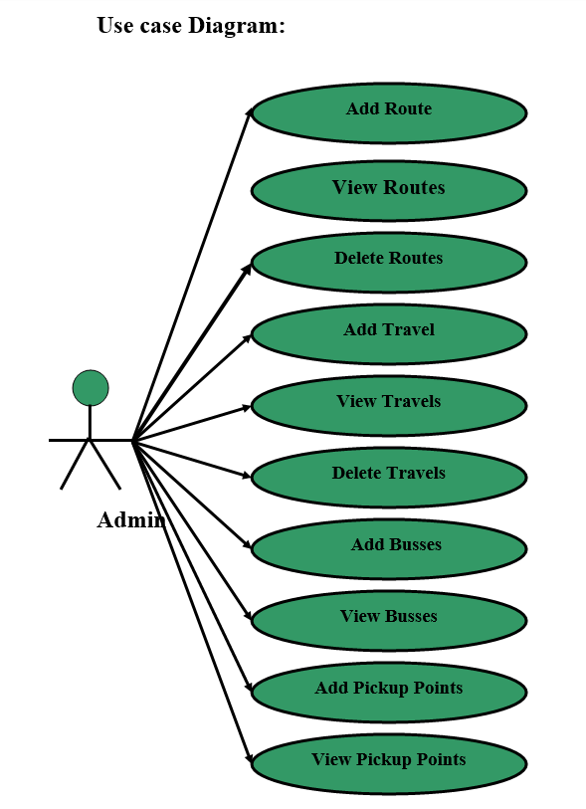

**Annexure D Data Dictionary (DD)**

**Example:**

**User Table (USR)**

|  |  |  |
| --- | --- | --- |
| **Fields** | **Data type** | **Description** |
| USR-Name | String | User name |
| USR-Password | String | User password |
| USR-Contact-No | Number | User Contact |
| USR-Address | String | City |

**Annexure E Screen Shots**

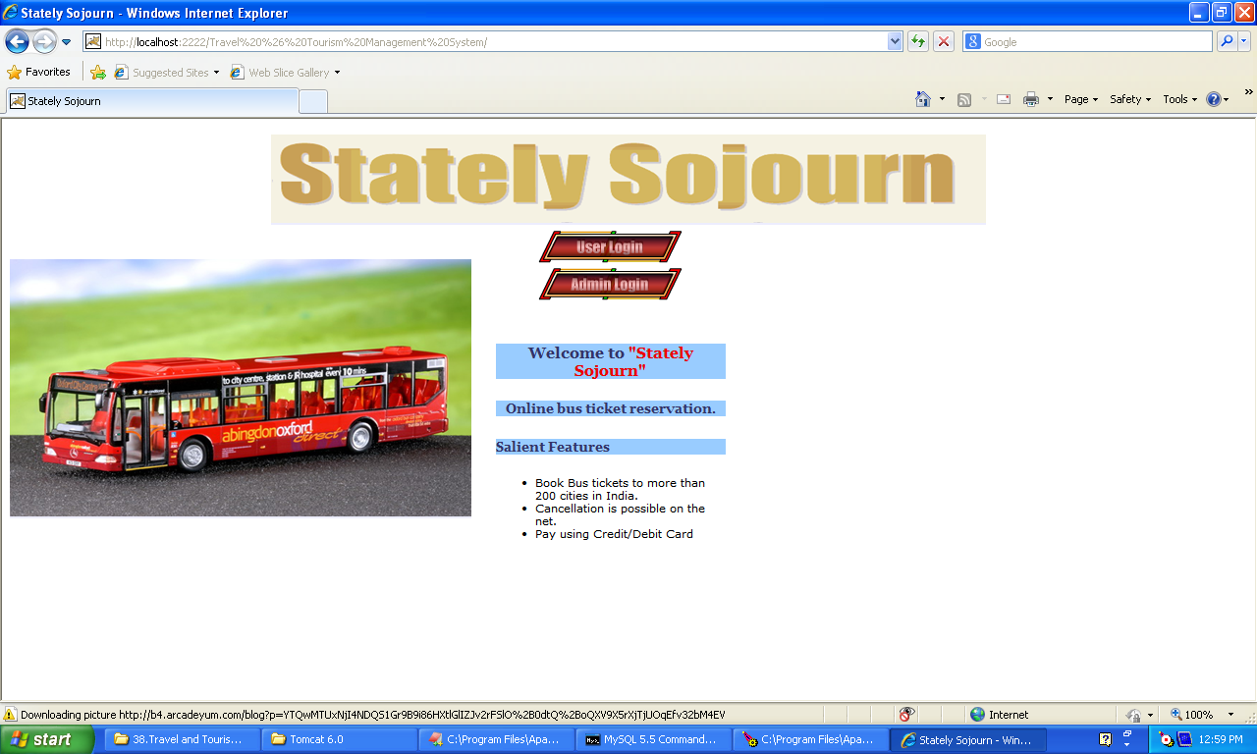**Home page:**

